Orator’s Report
on the 30th degree
Knight Kadosh
or Knight of the
White and Black Eagle
May 26, 2021
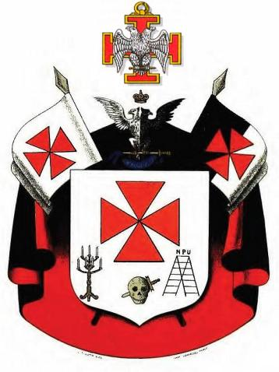
No apron is used
The jewel is a double-headed eagle, with outstretched wings resting on a Teutonic Cross

Bremerton Valley of the Scottish Rite

The Legend: The Traditional History of the Order gives the history of the Knights Templar from their formation in the year 1118, through their betrayal in 1307, and the trial and martyrdom of their Grand Master in 1314.
The Setting: the bodies of this Degree are styled into four apartments. The reception in the first apartment is within the burial chamber of the Chapter.It has black hangings and a dimly lit tomb with a coffin and three skulls representing the 14th century Pope, Jacques de Molay, and the King of France. The second chamber announces the duties of a philosopher and a Knight Kadosh. It has hangings of gold and white. The third apartment is set within the Frank Judge’s Tribunal chamber. This apartment has hangings that are light blue and hung with crimson, except in the east, which is hung with black and embellished with skulls pierced by daggers. The fourth apartment is the Council Chambers displaying the double headed eagle, where the aspirant is presented with his responsibilities. On the alter is the JBM labeled urn with black cloth and laurel surrounded by a Regal Crown, a Pope’s Tiara, a dagger, and various religious symbols including a cross. The most elaborate symbol in this degree is the Mystic Staircase. On the one hand, the rungs represent the seven liberal arts and sciences of the ancients presented in the Fellowcraft degree. In addition, the Mystic Staircase has seven rungs of a more esoteric or mystical meaning. Pike roughly corresponds some of them to parts of the Sephirotic Tree of Life of Kabbalah.
The Ritual: To obtain the rank of Knight Kadosh, the Aspirant must bind himself with the threefold vow of obedience, temperance, and fidelity in the war against ignorance, tyranny, despotism and vice. The second apartment sets out to teach the candidate to learn to pursue with feet that never tire and eyes that never sleep and so labor unceasingly for the Good of Mankind. Its goals are to teach that Masonry does not aim for utopia but rather that people will have such institutions and governments as it is fitted for them to have. In the third apartment the Aspirant stands before the Frank Judge’s Tribunal where he sacrifices his own personal ambitions and desires on the altar of truth. In the fourth Apartment the aspirant vows to promulgate the enlightened concepts influenced by the “Declaration of Rights of Man and of the Citizen (1789)”* - Liberty, Equality, Fraternity - i.e. self-government, freedom of religion, enlightened education, separation of church and state.

*The Declaration was originally drafted by the Freemason Marquis de Lafayette, in consultation with Thomas Jefferson.
The Lecture: The 30th Degree transitions from the 28th and 29th Degrees. Within this transition are found many lessons, teaching us reverence and obedience to the Diety, the service of Truth, the practice of Virtue and Innocence; and also to battle for Truth and Right, Free Speech, and Free Thought; and in this to defend the people against tyranny. The chivalric ideals, remind us that Masonry involves the pursuit of knowledge and the practice of virtue. The overarching notion is that this degree is a summary of the overall teachings of the Council. All of which are derived from the previous degrees:
War against ignorance. The first and most vital foundation of the instructions of the Council is that knowledge is power. Education is said to expand one’s intellect and leads man toward the real understanding of what truth is.
War against despotism. Despots seek to control men’s actions and control men’s thoughts. Propaganda replaces education and freedom of the press becomes a conspiracy against a well-ordered society.
War against spiritual Tyranny. Spiritual tyranny is intolerance. It presumes to decide for man his earthly and spiritual destiny. It seeks to preserve the institution rather than the preservation of its teachings that maybe sublime.
War against vice. Vice is opposed to the moral nature of man; its armor is greed, its weapons ambition, fanaticism and superstition. As long as ignorance, weakness, and hunger exist and are exploited, the Knight Kadosh's job stands before him.

In this degree, the Mason learns that the main purpose of the degree is to realize, in action, the noblest feelings of man. Knight Kadosh's mission is to restore to man all his powers and all the dignity of manhood and to make the ancient description of man, who was made in the image of the Deity, come true again.
DUTIES: Work unceasingly for the good of humanity.
LESSONS: Arm yourself with faith in God, love for your neighbor and knowledge. Great examples are the noblest legacies of the past; they enrich a nation more than wealth or power.
TO REFLECT: Are chivalric virtues obsolete in the modern world?
IMPORTANT SYMBOLS: Three skulls, three funeral urns, the mystical staircase, the double-headed eagle.

The cordon is a watered black silk ribbon, four or five inches wide, edged with a narrow silver lace and worn across the body, from left to right. The letters "K" and "H" are embroidered in scarlet silk on the front of the cordon. They are the first and last letters of the Hebrew word "Kadosh: Also embroidered on the cordon are two Teutonic crosses and a double-headed eagle, with outstretched wings, holding a dagger in its claws. The two heads and the blade of the dagger are of gold. The handle of the dagger is oval, half white and the other black. The colors represent the division of good and evil in the universe.
The jewel is a double-headed eagle, with outstretched wings and measuring approximately one inch from the outside to the outside of the wings. The eagle rests on a Teutonic Cross one and a half inches in size. The eagle is made of silver and the cross of gold, enameled in red.

Adapted from Rex R. Hutchen’s book A Bridge to Light

